**Ideation Phase**

**Brainstorm&Idea Prioritization Template**

|  |  |
| --- | --- |
| Date | 19 sep 2022 |
| Team ID | PNT2022TMID49425 |
| Project Name | Smart lender applicant credibility for loan approval |
| Maximum Marks | 4 Marks |
| TEAM MEMBERS | M . Pooja(Team leader)  G . Mohanapriya  R . Sivasathya  M . Yuvarani |

**Brainstorm & Idea Prioritization Template:**

**PROBLEM STATEMENT**

**How to make lending easier and simpler without the financial loss ?**

The lending can be simpler if the device is smart and easy to access and the discussion of the team as follows 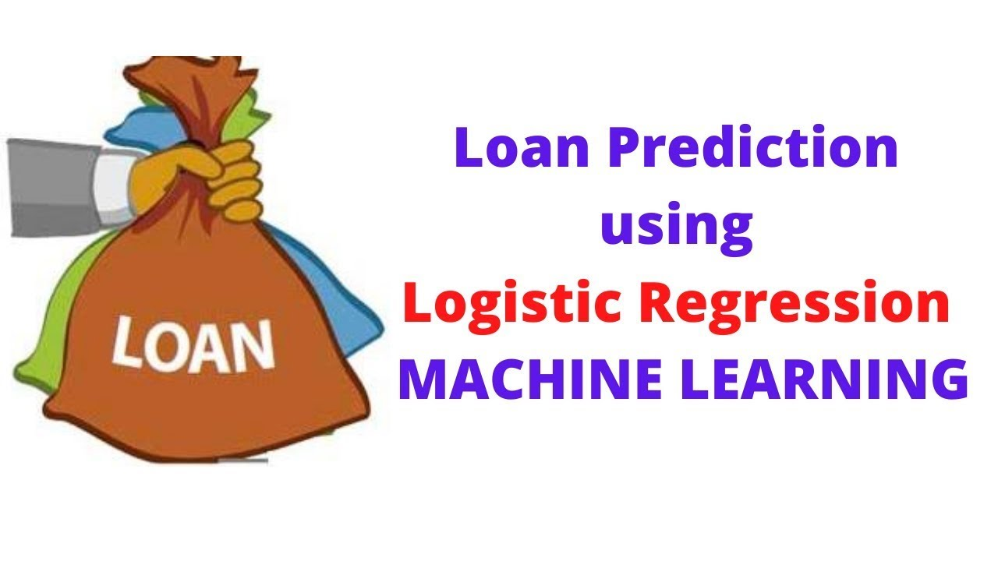

**Team member 1 idea**:

The idea of the team member 1 is making the project with the univariate analysis with the salary proof should be considered .The client’s basic details should be considered as the eligibility of the customer .The efficient transaction will be the lender satisfaction and the receiver repayment.

**Team member 2 idea:**

The idea of the team member 2 is using the bivariate analysis with the regression concept will be easier to complete this project and this lending system should be quite complex to crack with hacking and should be even and sharp in the data file entered and much better prediction.

**Team member 3 idea:**

*T*he idea of the team member 3 is using the decision tree will be easier to predict than the other schemes but the concept is using the python will be platform independent language and the software prediction is must in the lending process .The concept should be consider every details and the age consideration including the monthly expenses of the family.

**Team member 4 idea:**

The idea of the team member 4 is using the machine learning concept and using the variate analysis and the basic details should be consider eed and the age and the salary wage and the details should be considered .The regression can be used and machine learning data science and analytic will be easier for prediction.

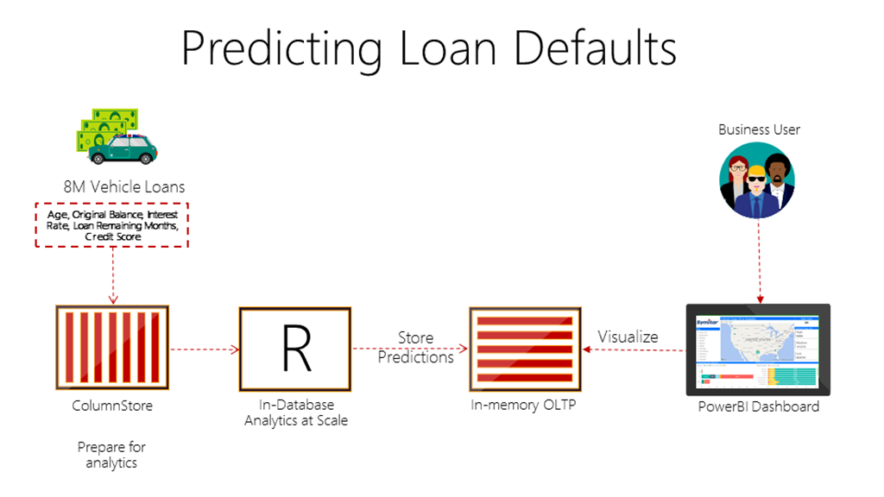

**PRIORITIZED IDEA:**

The prioritized idea will be using the univariate bivariate analysis and the basic details

should be considered with the machine learning and decision making and lending should be

proper .Data science and analysis is used in the smart lending system .The parameters should be

considered are age, gender,salary details and several important parameters.